1. Launching an EC2/VM in azure and aws. Connect using ssh through Powershell/Git Bash/Terminal/MobaXterm.

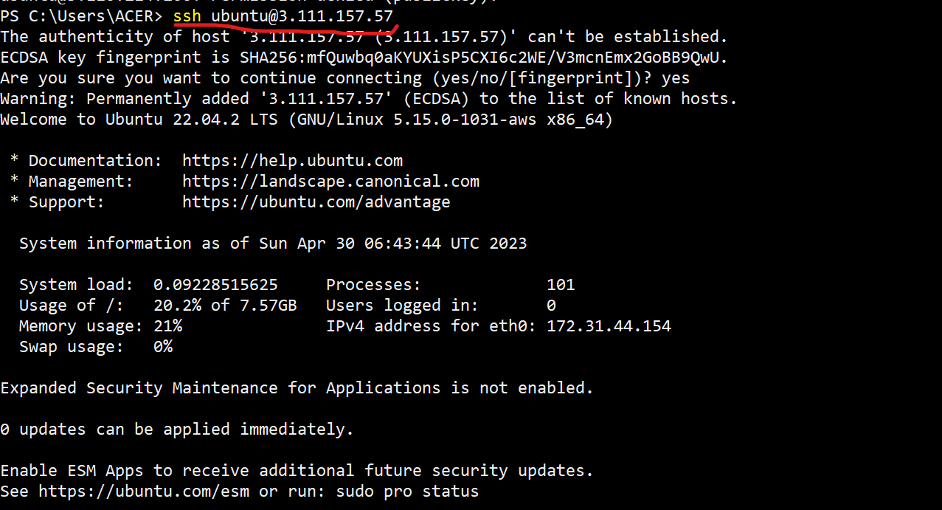

2.Install required softwares using chocolatey

Winscp  
 Notepadplusplus  
 Vscode  
 Putty  
 MobaXterm   
 BeyondCompare

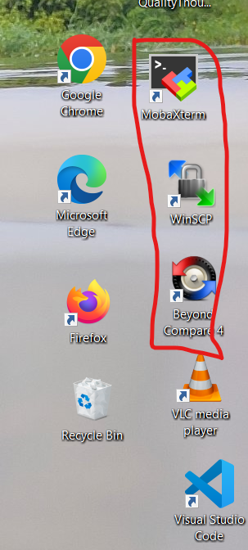

3. Create a Security Group/NSG in AWS/Azure and assign 22,80 and 443 ports.

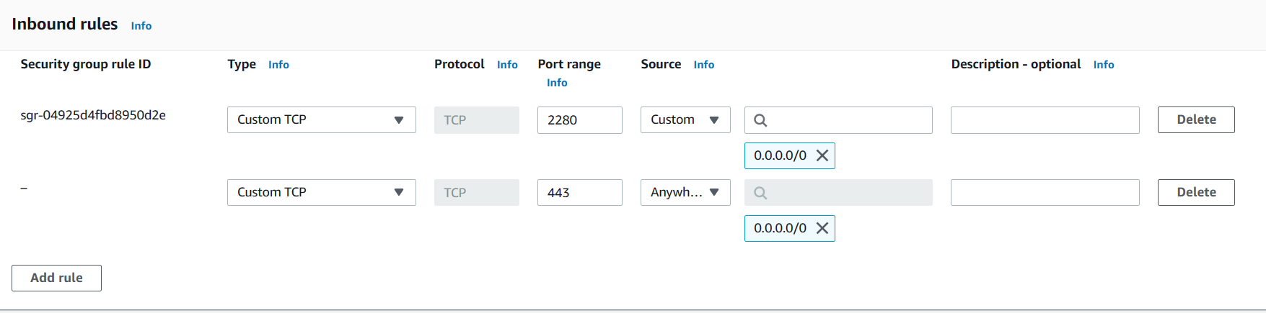

4. Create a keypair in AWS.

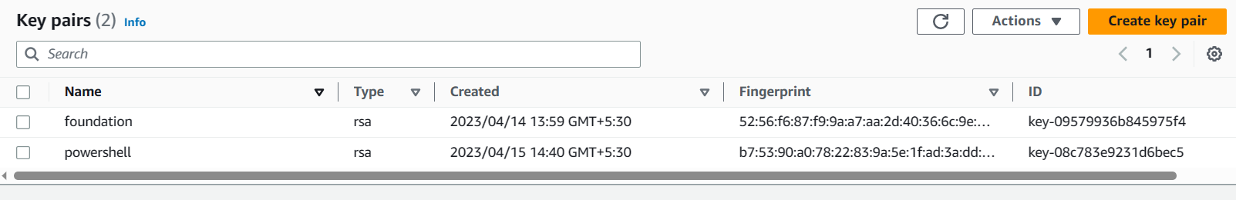

5. Create users using adduser/useradd/deleteuser/deletegroup/removeuserfrom group and assign passwords and group creation and add the existing user to the group.

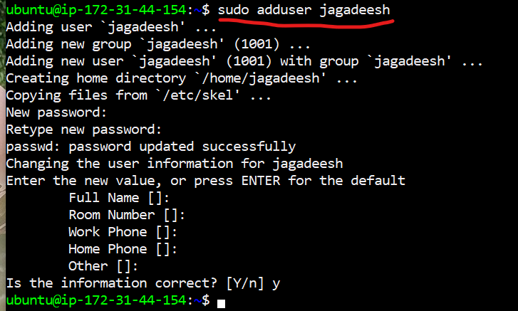

6. Find the location of users,passwords and groups

